Contents

Pages 2-3 Introduction

Pages 4-5 Policy Summary

Pages 6-7 Intercity Services

Page 8 DART & Commuter Services

Page 9 Stations

Page 10-11 Lifts

Page 12 Ramps

Page 13 JAM Cards

Page 14 Please Offer Me A Seat Badge

Pages 15 Priority Seating

Page 16 Car Parking

Pages 17-18 Wheelchair & Mobility Scooters

Pages 19-20 Guide Dogs & Assistance Dogs

Pages 20-21 Planned & Unplanned Disruptions

Page 22 Free Travel Passes (Standard Class)

Page 23 Quieter Coach

Page 24 Changing Places

Page 25 Sensory Packs

Page 26 Digital Accessibility

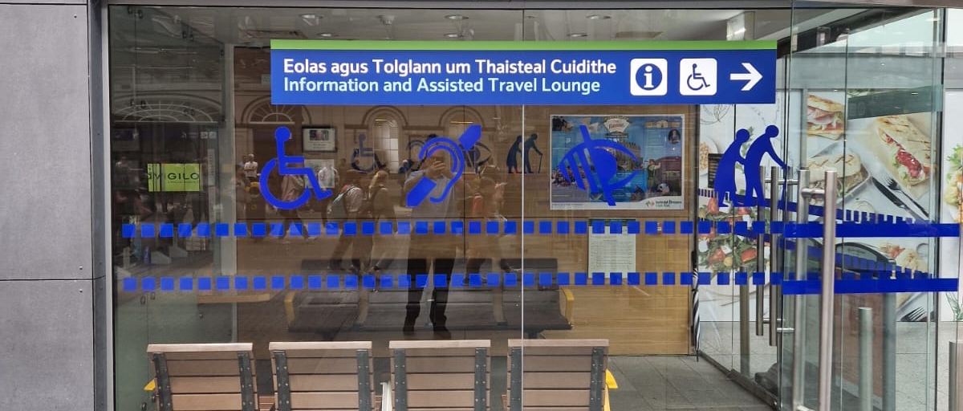
Picture above is of the Assisted Travel Lounge at Heuston station.

Dear Customers,

Iarnród Éireann is committed to providing customers with an excellent customer experience every time they travel with us.

This guide is designed to ensure that information is available to customers with disabilities to make it easier to use our services. Every carriage on our network is now wheelchair accessible and we have also made significant improvements in station facilities with a programme of works dedicated to making stations fully accessible.

The needs of customers with disabilities have been a priority when purchasing new rolling stock and upgrading facilities.

In 2024, 52,500 customers with a disability received assistance from our staff while travelling on our services.

I meet with our Disability User Group on a quarterly basis, and I have regular meetings with Disabled Persons Organisations throughout the year. I have a Quarterly Accessibility newsletter outlining the latest news and developments and you can be added to the distribution list by emailing, access@irishrail.ie

I would like to thank you for travelling with us, and hope you find this guide useful. I would also welcome your feedback on both its contents and how you feel we can make rail journeys easier and more accessible for all.

Ronan Murphy,
Head of Customer Care & Accessibility



Picture above of Ronan Murphy
Policy Summary

Iarnród Éireann is committed to achieving the goals of the UN Convention on the Rights of Persons with Disabilities (UNCRPD).

At Iarnród Éireann, we build the needs of all people into our planning process, from the development of trains and stations to making it easier to use our network.

We consider and review appropriate reasonable suggestions to ensure that customers who need extra assistance are treated, as laid out in the Equality Act (2010) and ensure we are compliant with EU legislation on rail passengers rights.

Iarnród Éireann endeavours to help all customers who need assistance, to travel on our rail services. We also comply with European Regulations regarding accessibility of rail systems for persons with disabilities and persons with reduced mobility.

We are continuously improving the way services and facilities are delivered to our customers with a disability.

Our current Disability User Group is independently chaired by Tony Ward who is visually impaired. The other organisations represented are as follows: Voice of Vision Impaired, Headway Ireland, The Alzheimer’s Society of Ireland, As I Am, Kildare Access Group, Cork DPO, Irish Guide Dogs for the Blind, The Irish Deaf Society, The Irish Wheelchair Association, Vision Ireland and Central Remedial Clinic.

Our Disability User Group mission is to be a key contributor to the transformation of all Iarnród Eireann services to be universally accessible to, and inclusive of, everybody.

All customer-facing staff of the company are provided with accessibility training.

Our vision is to offer best in class accessibility training to our frontline staff who interact with customers with a disability daily.

Assistance while using Intercity Long-distance Services

For customers travelling on Intercity services who require assistance, we will be better able to assist you if you contact us in advance.

Advance arrangements can be made by calling our Customer Contact Centre on 0818294015
07.00am – 7pm Monday to Friday
08.00am - 6pm Saturdays
10am – 6pm Sundays and Public Holidays

The Customer Agent will note details of your proposed journey and arrange assistance at your departure and arrival stations (and at intermediate stations if you need to change trains), and any other relevant information.

Assistance arrangements may also be made by emailing access@irishrail.ie which is monitored Monday to Friday 09.00-17.00 hrs.

Prior notice will ensure that a staff member will be available to both assist you board the train (and at changeover stations) and alight at your arrival station. Customers are advised to arrive in good time prior to departure of the train, and if carrying excess luggage, are advised to travel with a companion.

If you need to cancel your journey for which special arrangements have been made, please let us know so that the staff will be available to assist other Customers.

The following stations have 1 hour notice periods:

Heuston Station, Dublin
Connolly Station, Dublin
Limerick Junction and Colbert Station, Limerick
Mallow station and Kent station, Cork
Killarney Station and Tralee station
Kilkenny Station and Waterford Station
Athlone station and Galway Station
Sligo station
Ballina station and Westport station.

All other Intercity stations require 4 -12 hours advance notice period. Seats and Wheelchair Spaces will still need to be booked online on www.irishrail.ie

Assistance while using DART & Commuter Services

For Customers travelling on the DART and Commuter services who require assistance, please give 4 hour’s notice.
Our zonal system has one station in each zone that will be fully staffed (a Hub station) and will provide support to other stations in that zone. For contact details see our website:
https://www.irishrail.ie/en-ie/travel-information/accessibility-onboard-trains/access-dart-northern-commuter

For the Cork/Cobh/Midleton commuter zone and Phoenix Park Tunnel services, customers requiring assistance should contact
our Customer Contact Centre on 0818294015

07.00am – 7pm Monday to Friday
08.00am - 6pm Saturdays
10am – 6pm Sundays and Public Holidays

If possible, we will arrange assistance at shorter notice for urgent journeys.

Stations

All new railway stations have been designed and constructed in accordance with accessibility standards/best international practice. An accessibility refurbishment programme to make existing railway stations more accessible is continuing. For up to date information about accessibility at our stations, please use these links: http://www.irishrail.ie/travel-information/your-travel and select your station, or http://www.irishrail.ie/travel-information/disabled-access

A major area of focus for our capital investment programme has been to improve existing lifts, and to put in new lifts and footbridges at stations where previously there have been inaccessible platforms.

Lift Renewals
This programme, funded by the NTA (National Transport Authority), has seen over 50 lifts benefit from upgrades since 2020, ranging from complete replacement to control panel and other system renewals.

Additionally, most of our stations with lifts have the Customer Lift Call system in operation.

The system provides monitored access to lifts to prevent anti-social behaviour, a significant factor in the past in lift availability issues. To access the lift, the customer presses a help point located at each landing of the lift shaft. Our monitored centre is always operational when trains are running and can immediately see CCTV and can ensure that access for anti-social behaviour reasons is prevented.

2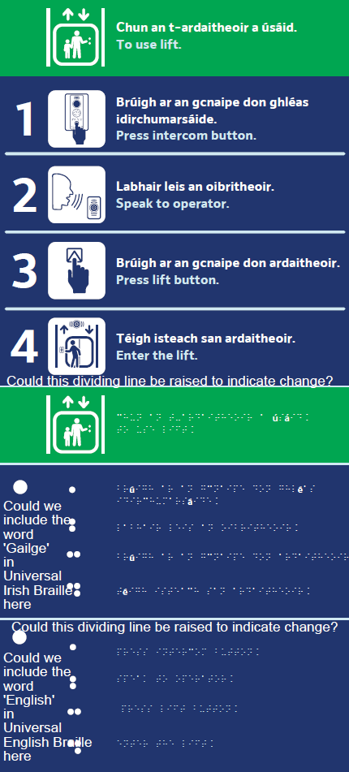

Pictured above is a description of the Lift call process that is displayed outside the lift.
1 Press Intercom Button. 2. Speak to operator. 3. Press lift button. 4. Enter the Lift
Ramps
At some stations there is a gap between the platform and the carriages which may create difficulty for people who are visually impaired, use wheelchairs or have mobility impairments and assistance may be required when boarding or alighting from the train.
Ramps are inspected regularly and there is a minimum of 1 ramp in every station, higher number in larger stations.

Our staff will use ramps to help you on or off our trains as required.
Picture above of customer using ramp assisted by staff member.
Jam (Just A Minute) Card
The JAM Card was created by the NOW Group, a social enterprise that supports people with learning difficulties and autism into jobs with a future. Their service users told them that they would like a way to relay to people that they need a little extra time or patience.
For those with a learning difficulty, autism, Asperger’s or any condition where there can be a communication barrier, the JAM Card allows users to relay to others that they may need a little extra time in a simple, effective non-verbal manner.
JAM card is available from major train stations or by emailing access@irishrail.ie
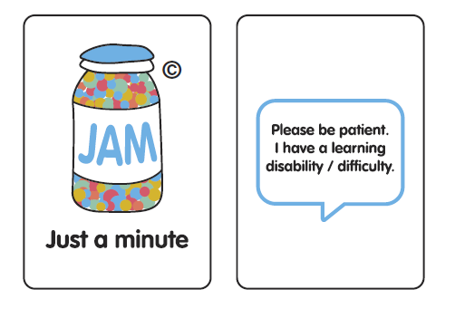
Picture above of the JAM Card.
Please Offer Me A Seat Badge
The “Please Offer Me a Seat” Badge and Card was created by Transport for Ireland in partnership with Invisible Disability Ireland for people with invisible disabilities to use when accessing public transport. About 80% of all disabilities are invisible and can hinder a person’s efforts to go to school, work, socialise, and more. Invisible disabilities make up a large percentage of disabilities but may have little representation, awareness, understanding or support. The “Please Offer Me a Seat” Badge and Card ensure that people with hidden disabilities have a seat in priority areas on public transport.
For passengers with invisible disabilities, our badge does the talking
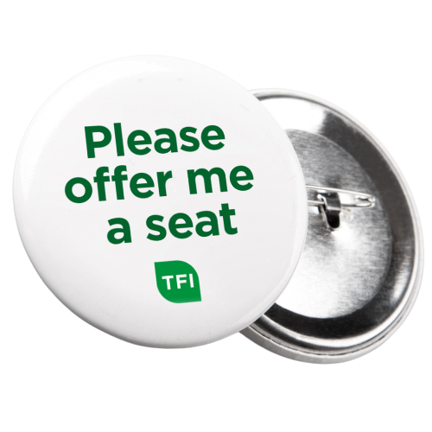
Picture above of the Please offer me a seat badge.

Priority Seating

There is priority seating on all our trains, usually near the doors with signage on the window.
Most people are happy to give up their seat to someone more in need of it. Simply show your JAM card or Please Offer Me A Seat badge to someone sitting in a priority seat and they’ll see that you have a need for one of these seats. Our customers have told us that this helps to avoid embarrassment. You are not guaranteed a seat if the priority seats are already taken by others with priority cards or who otherwise may need to sit down.

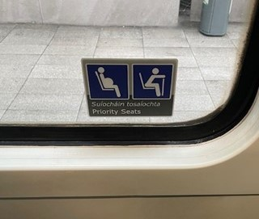
Picture above of Priority Seating Signage on Window.

Car Parking

All stations with car parks have designated car parking spaces for European Parking Card holders (see below). They are provided at a convenient location on a concrete or tarmac surface, with dropped kerbs and non-slip pavements where appropriate. Our carpark operator regularly monitors usage of designated car parking spaces to ensure that customers without the appropriate European Car Parking Permit are not utilizing these spaces.
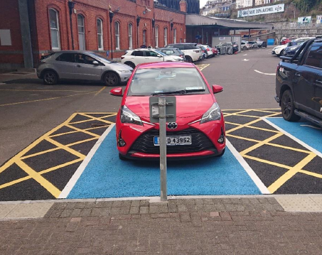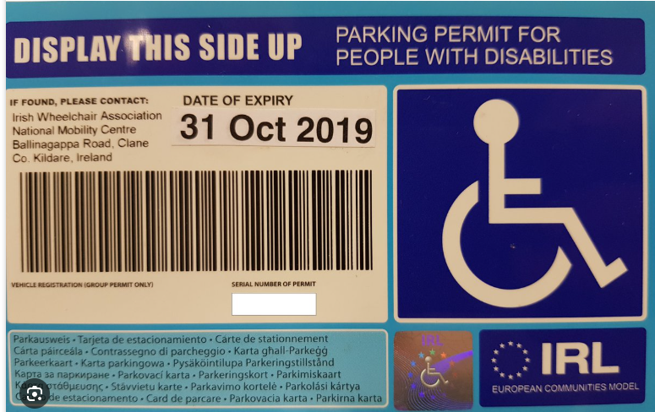
Pictured above Car Park Blue Badge Permit and Picture of disability parking space at Kent station in Cork.

Wheelchairs and Powered Scooters on Trains

Trains with wide, power-operated doors and dedicated wheelchair spaces operate on most of our services. It should be noted that at some stations there is a gap between the platform and the carriages which may create difficulty for people who are visually impaired or have mobility impairments and assistance may be required when boarding or alighting from the train.

On Intercity trains, there are a limited number of wheelchair accessible spaces available, and it is important to book your space in advance.

We can accommodate wheelchairs or powered scooters up to 700mm in width and 1200mm long (including footplates) height 1435mm including occupant a maximum weight of 300kg including occupant and a turning radius of 900mm.

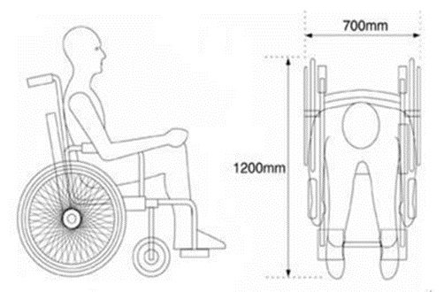

For safety reasons If your wheelchair or mobility scooter is larger than the permitted dimensions, we cannot accept it as the wheelchair or scooter may not be able to turn corners on board the train.

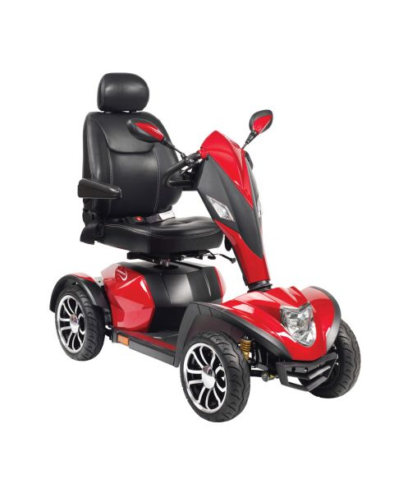
The photo above is of a large four-wheel scooter that cannot be accommodated onboard our services.

For safety reasons you are not allowed to sit on a scooter during your journey and must be able to walk to a nearby seat. As space on our services is limited, wheelchair users will have priority over the designated wheelchair/mobility scooter spaces. Powered wheelchairs and mobility scooters must not exceed walking speed (6 kph.) within stations and on platforms.

Guide /Assistance Dogs and Puppies in Training

Guide/Assistance dogs and Puppies in training are permitted to travel on all Iarnród Éireann services without restriction. A Guide/Assistance dog must be clearly identifiable either by coat or harness to distinguish it as a working dog and not a pet.

Puppies in Training. In the initial months of training, a puppy is identifiable by a yellow lead sign which bears the Irish Guide Dogs for the Blind name and logo. Then the puppy wears a yellow jacket which bears the Irish Guide Dogs for the Blind name and logo before becoming accustomed to wearing the guide dog harness or assistance dog jacket. Their trainer carries suitable photo identification. Other assistance dogs, such as Autism assistance, will carry an appropriate jacket to identify them.

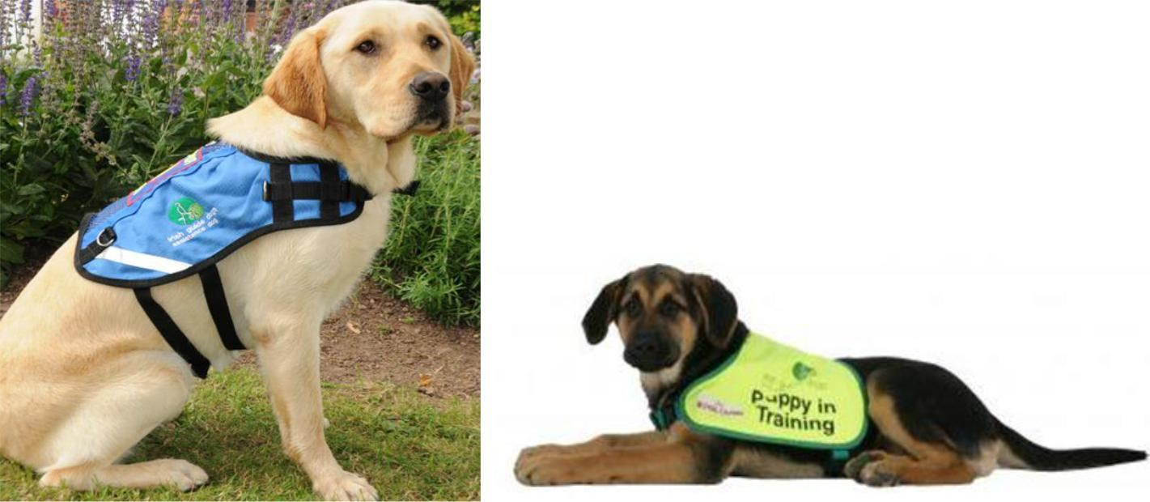

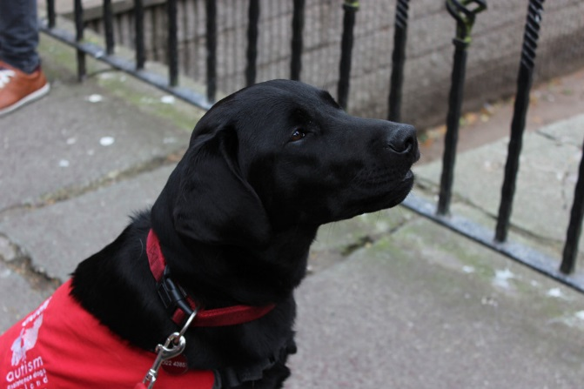

Pictured above are photos of three types of assistance dog’s coats in yellow, blue and red.

Planned Disruptions

Details of any planned disruption to services can be found on our website www.irishrail.ie

Customers who have booked assistance for disrupted services will be advised and informed of alternative arrangements.

If you have already been advised of the intended disruption when booking, but are unable to travel at another time, you (and one accompanying adult) will be provided with an accessible bus or taxi for that part of the journey where road transport has been involved (or for the whole of the journey if multiple changes between rail and road transport are involved).

Please note that we may not be able to provide alternative transport for unbooked scooters, unless they are of the “fold down” type that may be easily transported.

Unplanned Disruptions

Where unplanned disruptions occur, we will plan to provide alternative transport, calling at the same destinations as the intended train service.

If required, we will provide a taxi for customers with a disability and one accompanying adult as soon as possible. When trains are re-platformed at short notice, we will ensure that all passengers with mobility difficulties are assisted to the re-platformed train before it is despatched from the platform.

Free Travel Passes

Public Service Card Free Travel passes are issued by the Department of Employment Affairs and Social Protection.

If you have a Public Service Card Free Travel Pass, you may reserve your seat(s) by phone 0818294015 or via our website www.irishrail.ie by selecting the “Reserve Seat Only” option. If you book your seat well in advance of travel, then no charge will apply.

Passes must be produced at any time during the journey and if required, delivered up when requested by any official of Iarnród Éireann Irish Rail.
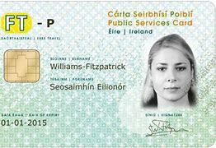
Picture above of a sample Public Service Card Free Travel Pass.
Quieter Coach

Following consultation with our Disability User Group, the Quieter Coach was launched on the Dublin to Cork route in 2022 with positive feedback received particularly those with a disability.
In the quieter coach, the noise should be kept down. Music through headphones should be kept quiet enough as to not disturb other customers and conversations should be conducted quietly.
The external door of the coach is branded in purple with Quieter coach as displayed below. Inside the Quieter coach there are internal decals advising customers that they are sitting in a Quieter Coach.
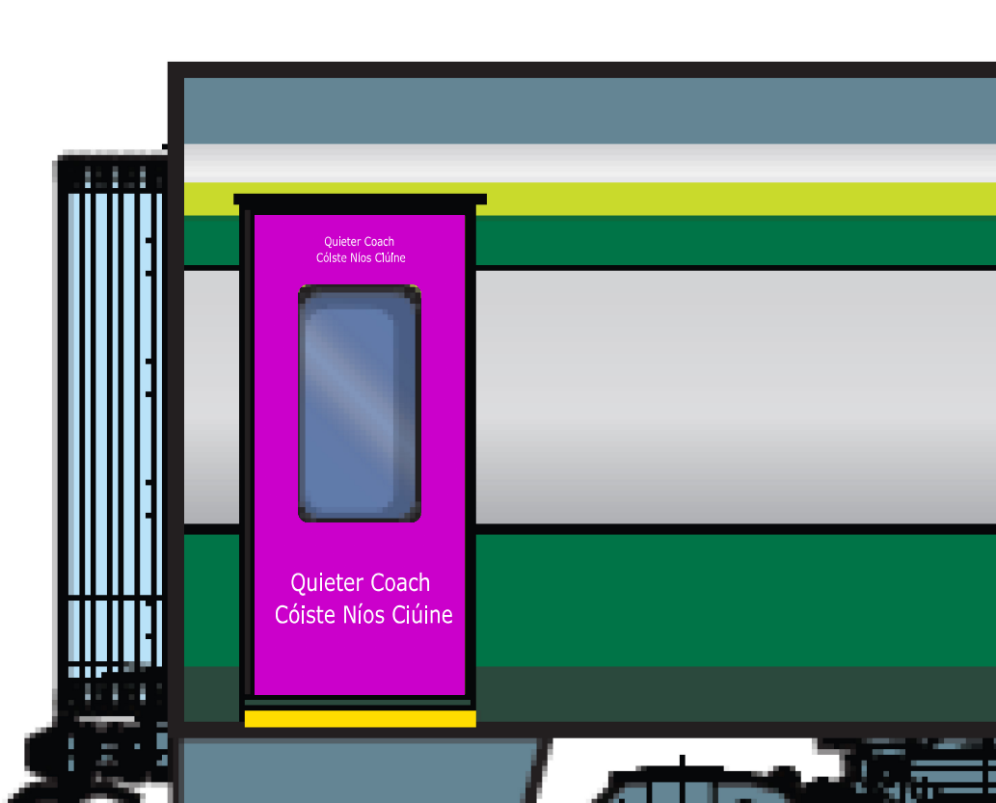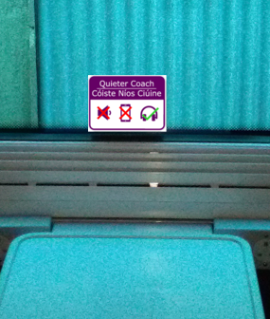
Pictured above are images of Quieter Coach purple door, signage describing the Quieter Coach inside the carriage and signage on the window.
Changing Places
There are three Changing Places facilities currently on the Iarnród Eireann network. Connolly Station, Dublin 1, Heuston Station, Dublin 8 and Colbert Station in Limerick with plans for further installation in Sligo and Athlone. All facilities are managed through the Station Cleaning staff who will open, close and clean the facility.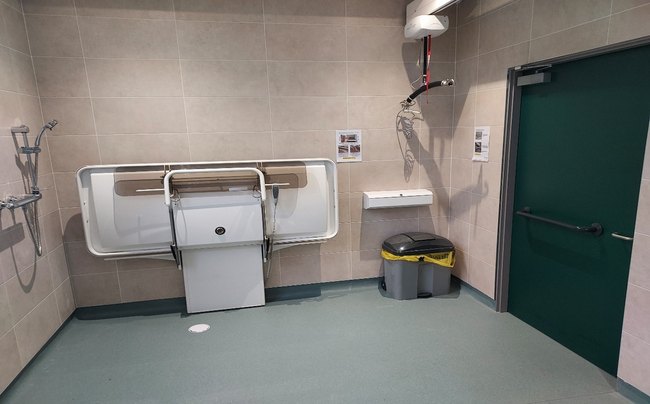
Picture above of Changing Places at Heuston station, Dublin.
Sensory Packs
Sensory packs are available for customers with additional sensory challenges. Our Disability User Group advised on contents. These packs contain ear defenders, sunglasses, a fidget spinner and sensory story and are distributed to customers travelling by rail with additional needs. These packs are free of charge and are proving to be extremely popular with customers.
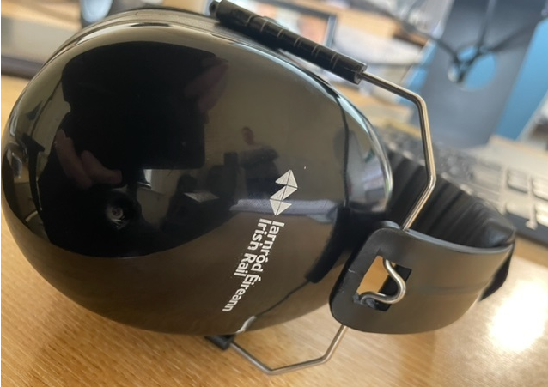
Picture above of Ear defenders from Sensory Pack.
Digital Accessibility
The Iarnród Éireann Digital team endeavours to provide information to the public in a clear, concise, and coherent manner which can be understood by all website users. Headings (H1, H2, H3 etc.) are used on webpages so that users of assistive technology such as Screen Readers can logically follow the structure and flow of the page and understand its content.

When drawing up specifications for any website agency tender, accessibility is one of the key requirements for any vendor to comply with, and verbiage is to be included in all specifications to ensure WCAG 2.1. AA and WCAG 2.2.

Feedback, please email access@irishrail.ie with any feedback on this document.

