

**Service Quality Report 2024**

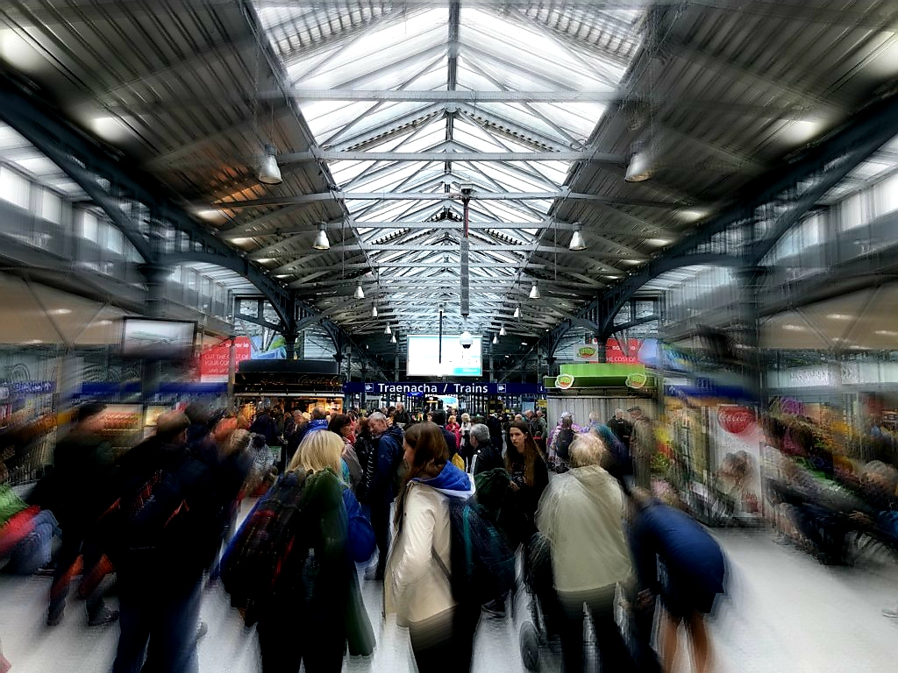

**Table of Contents**

1. Company Information.
2. Information and Tickets.
3. Assistance provided to customers with disabilities.
4. Train punctuality.
5. Customer Satisfaction Surveys.
6. Customer Experience.

1 **Company Information**

Iarnród Éireann provides passenger and freight rail services as well as operating Rosslare Europort.

Intercity rail passenger services operate between Dublin and Belfast, Sligo, Ballina, Westport, Galway, Limerick, Ennis, Tralee, Cork, Waterford and Rosslare Europort and Iarnród Éireann jointly operates the Dublin to Belfast Enterprise service with Northern Ireland Railways.

Regional services include the Limerick to Galway line, Cork commuter network including the Cork-Midleton line, Limerick Junction to Waterford, and Limerick to Ballybrophy (via Nenagh) services.

In addition to the DART service, which operates between Greystones and Howth/Malahide, we also run the commuter service in the Dublin area between Gorey, Drogheda, the M3 Parkway line and Maynooth, as well as the commuter service to Kildare.

**2 Information and Tickets**

**Our People**

Iarnród Éireann has customer service, telephone sales and disability assistance staff available to assist customers with any queries they may have [0818 294 015](tel:0818294015) or [+353 1575 6110](tel:+35315756110) opening hours are from 07.00-19.00 Monday-Friday and 08.00-18.00hrs Saturday, Sundays and Bank holidays. We also have staff on hand at our main stations to help customers. We expect our staff to be helpful, courteous and professional at all times.

**Customer Information**

We are committed to providing customers with clear, comprehensive and accurate information before travelling with us and during your journey.

We offer this information in a range of formats and media:

* Customer Information, including Passenger Assistance, Phone Line, [0818 294 015](tel:0818294015) or [+353 1575 6110](tel:+35315756110) from outside the Republic of Ireland
* Our website [www.irishrail.ie](http://www.irishrail.ie/)
* Station staff
* X - @IrishRail
* Iarnród Éireann (Irish Rail) Facebook page - www.facebook.com/iarnrodeireann
* Iarnród Éireann (Irish Rail) apps: iOS and Android

The **Enterprise Passenger’s Charter** for the Dublin/Belfast cross border service sets out standards for this line in more detail. Copies of this charter are available at stations on the route and online at: [Cross Border Rights](https://www.irishrail.ie/en-ie/legal/passengers-charter/international-rail-travel)

**Buying your ticket or Smart Card**

There are several ways customers can buy a ticket to travel with us.

The lowest intercity fares are available online by booking in advance at [www.irishrail.ie](http://www.irishrail.ie) .

Customers can also reserve premium, first class and standard class tickets online. Phone bookings, using a credit or debit card can be made between 07.00 and 19.00hrs Monday to Friday, excluding public holidays, [0818 294 015](tel:0818294015) or [+353 1575 6110](tel:+35315756110) from outside the Republic of Ireland and 08.00-18.00hrs Saturday, Sundays and Bank holidays.

Commuters can avail of great savings with Taxsaver tickets available through participating employers on a personalized Leap Card. See [www.taxsaver.ie](http://www.taxsaver.ie) for further details.

Customers in the Dublin and Cork city areas are advised to purchase a Leap Card giving savings of up to a 25% on single fares for adults, students and children between 4 and up to their 19th birthday. Leap Cards are available from Ticket Vending Machines (TVM) in all relevant stations. You can top up your Leap Card using cash or credit/debit card at any TVM or online at [www.leapcard.ie](http://www.leapcard.ie).

Customers can buy train ticket in a number of ways:

* Online at www.irishrail.ie, for Intercity rail travel
* At a ticket office. Check station opening hours on <http://www.irishrail.ie/travel-information/your-travel>
* At a ticket vending machine at the station
* By phone [0818 294 015](tel:0818294015) or [+353 1575 6110](tel:+35315756110). Opening Hours 07.00-19.00 Monday-Friday and 08.00-18.00hrs Saturday, Sundays and Bank holidays.

[Leap cards](http://Leapcards) may be purchased from:

* [www.leapcard.ie](http://www.leapcard.ie)
* Ticket vending machines in DART and Dublin commuter stations
* Child Leap Card 16-18 can only be purchased online. See <https://about.leapcard.ie/about/tfi-leap-card-types/child-16-18>

**At Stations with Staffed Ticket Offices**

Our staff will help customers choose the most appropriate ticket for their journey. Outside our busy peak hours, we aim to serve customers within three minutes. During peak hours, it might take longer, but we still aim to serve customers within seven minutes. This excludes exceptional circumstances. E.g. football matches, concerts, events etc.

**At Unstaffed Stations with Station Ticket Vending Machines**

Customers can buy a range of tickets from the ticket vending machines (TVM) that are in most stations. When buying a ticket from a TVM, customers must make their outward journey on the same day as you buy this type of ticket.

**3 Assistance Provided to Customers with Disabilities**

We welcome passengers with special needs, and we are committed to providing a service that everyone can use. Many of our stations and trains are accessible for passengers with special needs. We provide designated wheelchair spaces on our Intercity fleet.

We provide on-board changing facilities for parents travelling with babies and small children (except on DART services).

Full details of facilities in each station are in our ‘Guide for Rail Passengers with Disabilities’, which is available free online at: [www.irishrail.ie/travel-information/disabled-access](http://www.irishrail.ie/travel-information/disabled-access)

We can accommodate wheelchairs or powered scooters up to 700mm in width and 1200mm long (including footplates) height 1375mm including occupant a maximum weight of 300kg including occupant.

To help customers make their journey go as smoothly as possible, we now offer a facility where customers can arrange assistance at any station by contacting our Call Centre on [0818 294 015](tel:0818294015) or [+353 1575 6110](tel:+35315756110) Monday to Friday 07.00 to 19.00hrs and 08.00-18.00hrs Saturday, Sundays and Bank holidays (excluding public holidays). We try to always give assistance, but we would like notice to allow us to make any special arrangements necessary.

**Equality and diversity**

We are committed to treating all customers equally and making sure that your rights under the Equal Status Act 2000 are fully respected. The Equal Status Act covers issues including: disability, age, gender, marital status, family status, sexual orientation, religious belief, race and membership of the Traveller Community.

**4 Train Punctuality**

* Punctuality = a measurement of timekeeping.
* For InterCity and Commuter, it is on time or within 10 minutes of time.
* For DART, it is on time or within 5 minutes of time.
* Reliability = whether the train operates or not.
* All performance figures are independently verified by the National Transport Authority.
* Punctuality figures include delays outside of Iarnród Éireann’s control.

**5 Customer Satisfaction Surveys**

Iarnród Éireann undertakes various types of research in order to ascertain customer satisfaction.

**Iarnrod Éireann Intercity satisfaction 91% in 2024.**

**Iarnrod Éireann DART/Commuter satisfaction 94% in 2024.**

**Customer Satisfaction Monitor**

The largest piece of research is the bi-annual customer satisfaction monitor carried out in spring and late summer each year. During this research over 12,000 customers are surveyed. The research is spilt into two categories, intercity routes and commuter routes.

The primary objective of the research is establish customer expectations and measures perceptions of the quality of the service provided at each stage of the customer journey. . This research also determines customer views on the relative importance of the main aspects of the service including;

* Frequency
* Capacity
* Cleanliness
* On-board facilities
* The provision of information
* Ticketing
* Value for money
* Station facilities

Overall satisfaction and individual route satisfaction is monitored. The likelihood to recommend (NPS) is also determined on a biannual basis by route. This research has been carried out over a number of years and this enable comparative analysis with previous years’ results. This research was undertaken at stations and on-board services.

**DART & Commuter Satisfaction**

**91% Spring**

**87% Autumn**

**Intercity Satisfaction**

**92% Spring**

**92% Autumn**

**Focus Groups**

From time to time, depending on the business requirement focus groups are undertaken to build on and develop further in-depth insights into customer and non-customer attitudes and opinions.

The above research is undertaken by external research companies.

**Internal and online customer**

Ad hoc quantitative research is carried out as required, using the internal database of customers. This database is used when the information is required rapidly. Also it is used to bridge the gaps in the areas not covered by the customer satisfaction monitor or to address them in more depth.

**6 Customer Experience**

Iarnrod Éireann put the customer at the heart of the business and our customers are central to everything that we do, and our objective is to always provide the best possible service.

**Compensation Payments**

**Discounts if you are delayed**

If, you are more than 60 minutes late arriving at your destination station, we will offer you discount vouchers to use when you buy future tickets or, issue cash compensation under Regulation (EC) No 2021/782 of the European Parliament.

The value of the vouchers, or cash compensation*, is based on the length of delay and the fare paid for the single journey affected, as follows:

| **Delay** | **Ticket Type** | **Compensation** |
| --- | --- | --- |
| If you’re delayed by 60  to 120 minutes | Weekly, Monthly or  Annual ticket holders | *25% cash refund for that day pro rata on cost of ticket |
| Intercity Single or  Return ticket holders | 50% in vouchers or 25% in cash refund, Customer choice |
| If you’re delayed by 120 minutes or more | Weekly, Monthly or  Annual ticket holders | *50% cash refund for that day pro rata on cost of ticket. |
| Intercity Single or  Return ticket holders | 100% of the value of the single journey in vouchers or 50% in cash |

**At present, Iarnród Éireann do not offer compensation for cumulative delays for season ticket holders**

**Discounts if we fail to give you the service you pay for.**

If a customer’s booked seat is not available, and there is no other available seat of the same standard on the same train, we will refund customers the fare of their single journey back to the card on which the booking was made.

**Cancellation of your train, advanced notice/knowledge of a delay before your journey starts or during your journey.**

**If a customer’s train is cancelled in advance, if they are aware that their journey will be 60 minutes or more late arriving at their destination, we offer customers a choice between the following options:**

* **Customer may abandon their journey before starting it and receive a full refund of their booking/ticket.**
* **Customer may discontinue a journey they have already started and receive a refund for the part of the journey not taken.**
* **If the customer begins their journey, and their journey becomes pointless, they may return immediately to the starting point of their journey by train and apply for a refund of their booking/ticket.**